**Assignment15**

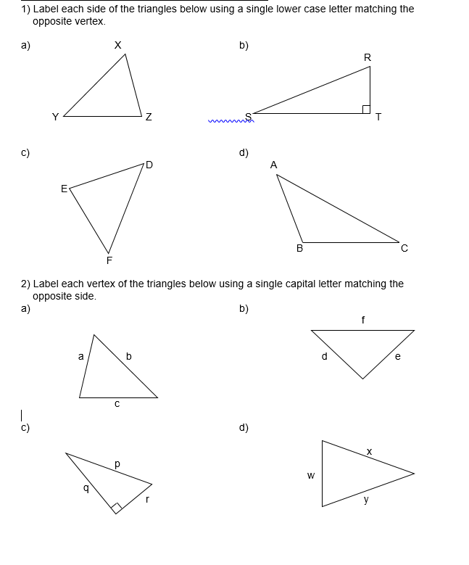

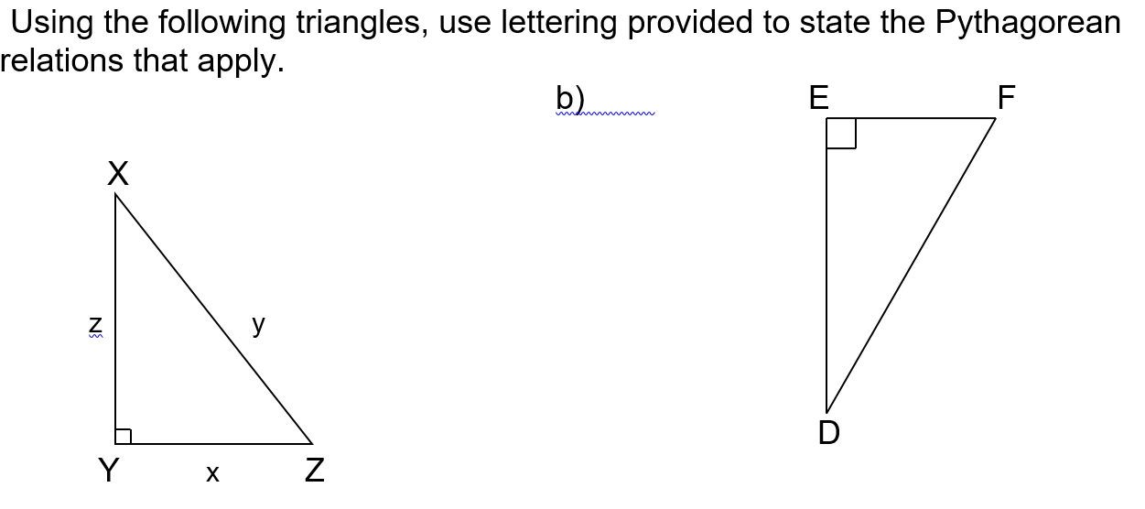

Find the missing value in each of the following to 2 decimal places. Remember to use the square root to solve for each final side length.

a) p2 = 92 + 62 b) m2 = 72 + 42

c) y2 = 82 – 52 d) z2 = 102 – 52

3) Calculate the missing side length (x) in each triangle to 1 decimal place (as needed).

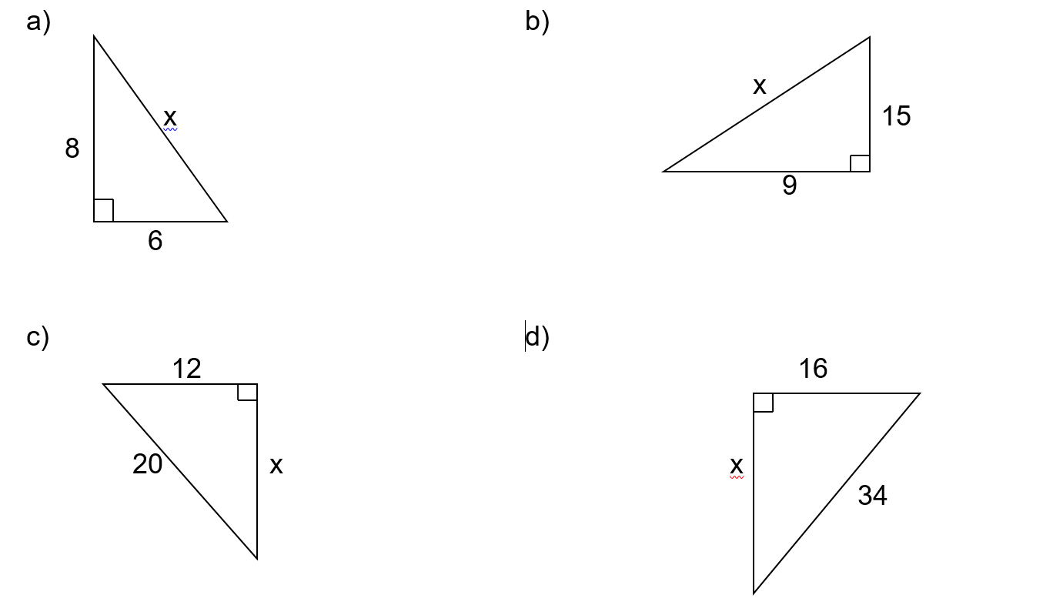

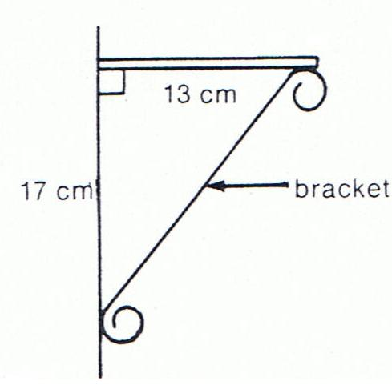1) Solve for the length of the bracket in the picture, to one decimal place.

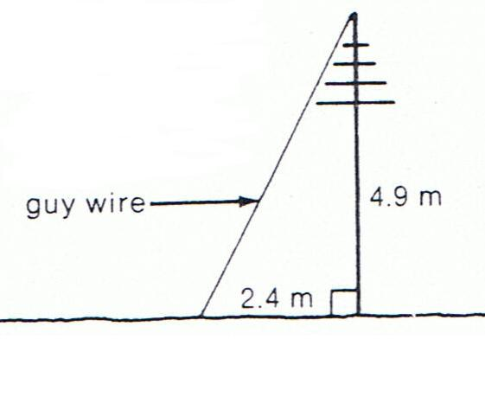2) What is the length of the guy wire in the picture below, to one decimal place?

3) A ramp into a house rises up (↑) 3.5 meters over a horizontal distance (→) of 10.5 metres. How long is the ramp? Use the triangle below and show your work.

4) You need to find the width of a lake, **PQ**, as shown. The measurements of the other sides are given on the diagram. You are certain that ∠P = 900. What is the width of the lake?

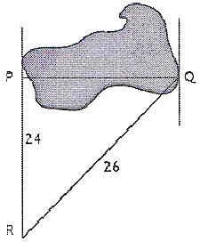

5) A ladder is leaned against a house. The base of the ladder is *d* feet away from the house. Draw a diagram and then write the Pythagorean relationship that exists for these lengths. Use *x*  for the ladder, *y* for the house, and *d* for the distance the ladder is from the house. You are *not* required to solve this question, just draw the diagram and write the relationship.

6) A 40 foot ladder reaches 38 feet up the side of a house. How far from the side of the house is the base of the ladder? Draw a diagram and show your work.

7) A flagpole is 12 metres tall. It makes a shadow on the ground that is 15 metres long. How long is a line that joins the top of the flagpole with the end of the shadow? Draw a diagram and show your work.

8) The size of a flat screen TV is given by the length of the diagonal of the screen (joining opposite corners). What is the length of a diagonal if the sides are 40.5 inches by 22.625 inches? Draw a diagram and show your work.